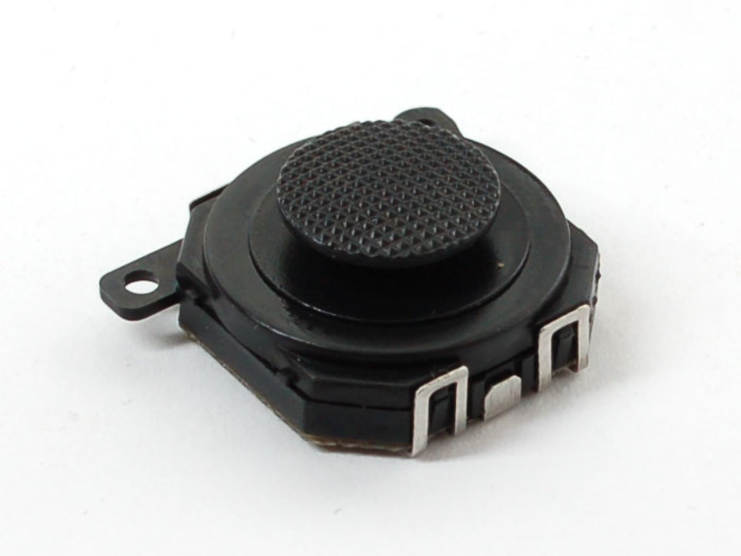

**PSP Joystick Tutorial**

1. **What does the Component do?**

The Component allows the user to Navigate through the messages and cycle through categories.

1. **How does the component work?**

When the user flicks the controller up and Down, it allows the user to scroll through categories. Flick the controller left and right allows the user to scroll through messages.

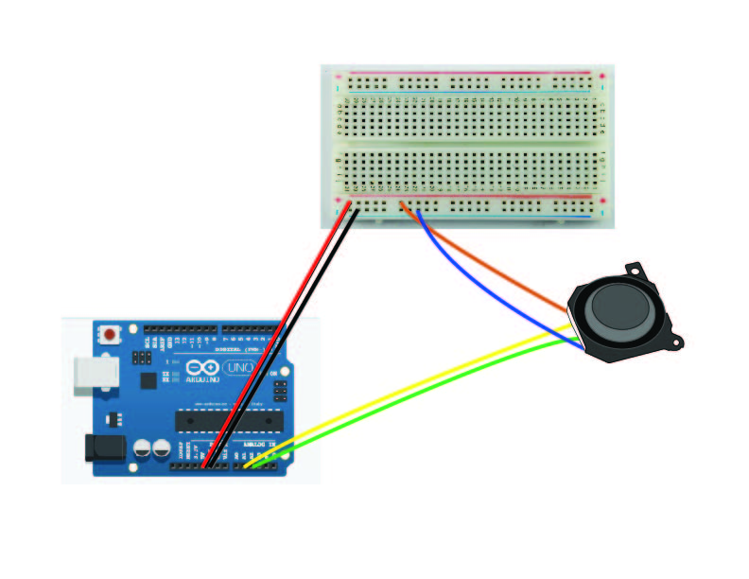

**Getting Started**

1. Solder the wire to the Joystick.
2. Power goes the 5V slot on the Arduino.
3. GND Goes to the GND slot on the Arduino.
4. Up and down wire goes to Analog 1 on the Arduino.
5. Right and Left Go to Analog 2.